**Exp – 1 Informed Search**

**A\***

**Code**

from collections import deque

*class* Graph:

*def* __init__(*self*, *adjacency_list*):

       self.adjacency_list = adjacency_list

*def* get_neighbors(*self*, *v*):

       return self.adjacency_list[v]

   # heuristic function with equal values for all nodes

*def* h(*self*, *n*):

       H = {

           'A': 1,

           'B': 1,

           'C': 1,

           'D': 1

       }

       return H[n]

*def* a_star_algorithm(*self*, *start_node*, *stop_node*):

       # open_list is a list of nodes which have been visited, but who's neighbors

       # haven't all been inspected, starts off with the start node

       # closed_list is a list of nodes which have been visited

       # and who's neighbors have been inspected

       open_list = *set*([start_node])

       closed_list = *set*([])

       # g contains current distances from start_node to all other nodes

       # the default value (if it's not found in the map) is +infinity

       g = {}

       g[start_node] = 0

       # parents contains an adjacency map of all nodes

       parents = {}

       parents[start_node] = start_node

       while len(open_list) > 0:

           n = None

           # find a node with the lowest value of f() - evaluation function

           for v in open_list:

               if n == None or g[v] + self.h(v) < g[n] + self.h(n):

                   n = v;

           if n == None:

               print('Path does not exist!')

               return None

           # if the current node is the stop_node

           # then we begin reconstructin the path from it to the start_node

           if n == stop_node:

               reconst_path = []

               while parents[n] != n:

                   reconst_path.append(n)

                   n = parents[n]

               reconst_path.append(start_node)

               reconst_path.reverse()

               print('Path found: {}'.format(reconst_path))

               return reconst_path

           # for all neighbors of the current node do

           for (m, weight) in self.get_neighbors(n):

               # if the current node isn't in both open_list and closed_list

               # add it to open_list and note n as it's parent

               if m not in open_list and m not in closed_list:

                   open_list.add(m)

                   parents[m] = n

                   g[m] = g[n] + weight

               # otherwise, check if it's quicker to first visit n, then m

               # and if it is, update parent data and g data

               # and if the node was in the closed_list, move it to open_list

               else:

                   if g[m] > g[n] + weight:

                       g[m] = g[n] + weight

                       parents[m] = n

                       if m in closed_list:

                           closed_list.remove(m)

                           open_list.add(m)

           # remove n from the open_list, and add it to closed_list

           # because all of his neighbors were inspected

           open_list.remove(n)

           closed_list.add(n)

       print('Path does not exist!')

       return None

adjacency_list = {

   'A': [('B', 1), ('C', 3), ('D', 7)],

   'B': [('D', 5)],

   'C': [('D', 12)]

}

graph1 = Graph(adjacency_list)

graph1.a_star_algorithm('A', 'D')

**Output**

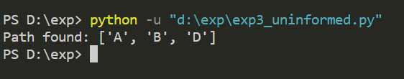

**Exp 2 - Uninformed Search**

**DLS**

**Code**

graph={

    'S':['A','B'],

    'A':['C','D'],

    'B':['I','J'],

    'C':['E','F'],

    'D':['G'],

    'I':['H'],

    'J':[]

}

*def* dls(*start*,*goal*,*path*,*level*,*maxLimit*):

    print('\nCurrent level -->',level)

    print('Goal node testing',start)

    path.append(start)

    if start==goal:

        print('Test successfull goal found')

        return path

    print('Goal node test failed')

    if level==maxLimit:

        return False

    print('Expanding current node:',start)

    for child in graph[start]:

        if dls(child, goal, path, level+1, maxLimit):

            return path

    return False

start='S'

goal=input('Enter goal:')

maxLimit=*int*(input("Enter max limit:"))

print()

path=*list*()

res=dls(start, goal, path, 0, maxLimit)

if(res):

    print('Path exists')

    print('Path',path)

else:

    print('Path doesnt exist')

**Output**

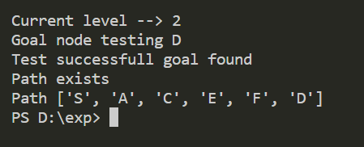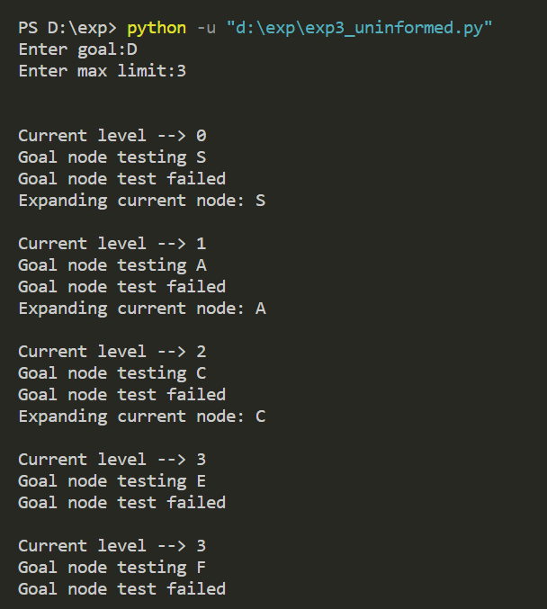

**Exp – 3 Minmax Algorithm**

**Code**

import math

*def* fun_minmax(*cd*, *node*, *maxt*, *scr*, *td*):

    if(cd == td):

        return scr[node]

    if(maxt):

        return max(fun_minmax(cd+1, node*2, False, scr, td),fun_minmax(cd+1, node*2+1, False, scr, td))

    else:

        return min(fun_minmax(cd+1, node*2, True, scr, td),fun_minmax(cd+1, node*2+1, True, scr, td))

scr = []

x =*int*(input("Enter total number of leaf Node = "))

for i in range(x):

    y = *int*(input("Enter leaf value: "))

    scr.append(y)

td = math.log(len(scr), 2)

cd = *int*(input("Enter current depth value: "))

nodev = *int*(input("Enter node value: "))

maxt = True

print("The answer is: ", *end*=" ")

answer = fun_minmax(cd, nodev, maxt, scr, td)

print(answer)

**Output**

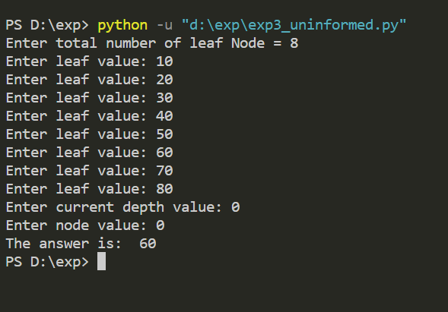

**Exp – 4 Alpha Beta Pruning**

**Code**

# Initial values of Alpha and Beta

MAX, MIN = 1000, -1000

# Returns optimal value for current player

#(Initially called for root and maximizer)

*def* minimax(*depth*, *nodeIndex*, *maximizingPlayer*, *values*, *alpha*, *beta*):

    # Terminating condition. i.e

    # leaf node is reached

    if depth == 3:

        return values[nodeIndex]

    if maximizingPlayer:

        best = MIN

        # Recur for left and right children

        for i in range(0, 2):

            val = minimax(depth + 1, nodeIndex * 2 + i,False, values, alpha, beta)

            best = max(best, val)

            alpha = max(alpha, best)

            # Alpha Beta Pruning

            if beta <= alpha:

                break

        return best

    else:

        best = MAX

        # Recur for left and

        # right children

        for i in range(0, 2):

            val = minimax(depth + 1, nodeIndex * 2 + i,True, values, alpha, beta)

            best = min(best, val)

            beta = min(beta, best)

            # Alpha Beta Pruning

            if beta <= alpha:

                break

        return best

if __name__ == "__main__":

    values = [4, 2, 6, 19, 1, -2, 3, -1]

    print("The optimal value is :", minimax(0, 0, True, values, MIN, MAX))

**Output**

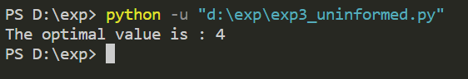

**Exp 5 - Constraint Satisfaction Problem**

**graph coloring**

**Code:**

colors = ['Red','Blue','Green']

states = ['Nagpur','Thane','Pune','Mumbai']

neighbors = {}

neighbors['Nagpur'] = ['Thane','Pune']

neighbors['Thane'] = ['Nagpur','Pune','Mumbai']

neighbors['Pune'] = ['Nagpur','Thane','Mumbai']

neighbors['Mumbai'] = ['Thane','Pune']

colors_of_states = {}

*def* promising(*state*, *color*):

    for neighbor in neighbors.get(state):

        color_of_neighbor = colors_of_states.get(neighbor)

        if color_of_neighbor == color:

            return False

    return True

*def* get_color_for_state(*state*):

    for color in colors:

        if promising(state, color):

            return color

*def* main():

    for state in states:

        colors_of_states[state] = get_color_for_state(state)

    print(colors_of_states)

main()

**Output**

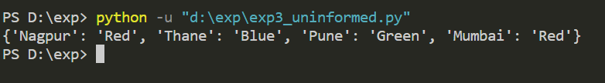

**N Queens**

**Code:**

# Taking number of queens as input from user

N = *int*(input("Enter the number of queens: "))

# here we create a chessboard

# NxN matrix with all elements set to 0

board = [[0]*N for _ in range(N)]

*def* attack(*i*, *j*):

   #checking vertically and horizontally if there are any queen placed

   for k in range(0,N):

       if board[i][k]==1 or board[k][j]==1:

           return True

   #checking diagonally if there are any queen placed

   for k in range(0,N):

       for l in range(0,N):

           if (k+l==i+j) or (k-l==i-j):

               if board[k][l]==1:

                   return True

   return False

*def* N_queens(*n*):

   if n==0:

       return True

   # here we are checking whether we can place queen at ith row and jth column

   for i in range(0,N):

       for j in range(0,N):

           if (not(attack(i,j))) and (board[i][j]!=1):

               board[i][j] = 1

               if N_queens(n-1)==True:

                   return True

               board[i][j] = 0

   return False

N_queens(N)

for i in board:

   print (i)

**Output**

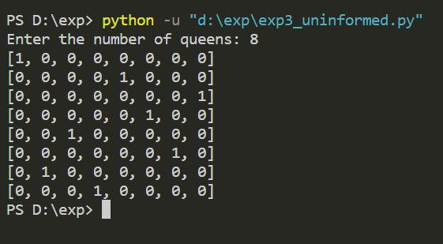

**Sudoku**

**Code**

N = 9

*def* printing(*arr*):

    for i in range(N):

        for j in range(N):

            print(arr[i][j], *end*=" ")

        print()

# Checks whether it will be legal to assign num to the given row, col

*def* isSafe(*grid*, *row*, *col*, *num*):

    # Check if we find the same num in the similar row, we return false

    for x in range(9):

        if grid[row][x] == num:

            return False

    # Check if we find the same num in the similar colum, we return false

    for x in range(9):

        if grid[x][col] == num:

            return False

    # Check if we find the same num in the particular 3*3 matrix , we return false

    startRow = row-row % 3

    startCol = col-col % 3

    for i in range(3):

        for j in range(3):

            if grid[i+startRow][j + startCol] == num:

                return False

    return True

# Takes a partially filled-in grid and attempts to assign value to all unassigned locations in such a way to meet the requirements for

*def* solveSudoku(*grid*, *row*, *col*):

    # Check if we have 8th row and 9th column(0 indexed matrix)

    if (row == N-1 and col == N):

        return True

    if col == N:

        row += 1

        col = 0

    # Check if the current position of the grid already contains value > 0 we iterate for next column

    if grid[row][col] > 0:

        return solveSudoku(grid, row, col+1)

    for num in range(1, N+1, 1):

        if isSafe(grid, row, col, num):

            grid[row][col] = num

            if solveSudoku(grid, row, col + 1):

                return True

        grid[row][col] = 0

    return False

grid = [[3, 0, 6, 5, 0, 8, 4, 0, 0],

        [5, 2, 0, 0, 0, 0, 0, 0, 0],

        [0, 8, 7, 0, 0, 0, 0, 3, 1],

        [0, 0, 3, 0, 1, 0, 0, 8, 0],

        [9, 0, 0, 8, 6, 3, 0, 0, 5],

        [0, 5, 0, 0, 9, 0, 6, 0, 0],

        [1, 3, 0, 0, 0, 0, 2, 5, 0],

        [0, 0, 0, 0, 0, 0, 0, 7, 4],

        [0, 0, 5, 2, 0, 6, 3, 0, 0]]

if (solveSudoku(grid, 0, 0)):

    printing(grid)

else:

    print("no solution exists")

**Output**

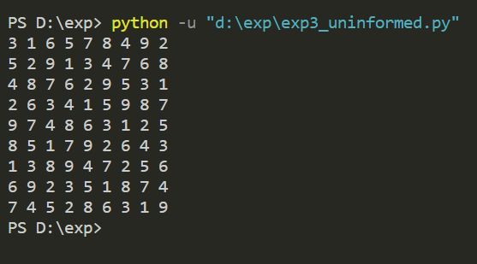

**Exp - 6 Local Search**

**Code**

from random import *

import random

import numpy

import copy

countCities = 20;

# 2D Array

cities = numpy.zeros(*shape*=(20,20))

# tour

hypothesis = [*int*]*countCities

visitedCities = []

saveState = []

threshold = 2

lastFitness = 0

trials = 0

cityIndex = 1

# calculates fitness based on the difference between the distances

*def* getFitness(*fitness*, *hypothesis*, *saveState*, *cities*):

    oldDistance = getDistance(cities, saveState)

    print("Old Distance ",oldDistance,"km")

    print("")

    newDistance = getDistance(cities, hypothesis)

    print("New Distance ",newDistance,"km")

    print("")

    if(oldDistance > newDistance):

        fitness += 1

    elif(oldDistance < newDistance):

        fitness -= 1

    return fitness

# choose random City at position cityIndex

*def* doRandomStep():

    global visitedCities

    global saveState

    global hypothesis

    if(len(visitedCities) >= countCities):

        visitedCities.clear()

        visitedCities.append(0)

    randomNumbers = *list*(*set*(saveState) - *set*(visitedCities))

    randomStep = random.choice(randomNumbers)

    visitedCities.append(randomStep)

    hypothesis.remove(randomStep)

    hypothesis.insert(cityIndex,randomStep)

# next city

*def* increment():

    global cityIndex

    global visitedCities

    if (cityIndex < countCities - 2):

        cityIndex += 1

    else:

        visitedCities.clear()

        cityIndex = 1

# calculates distance from tour

*def* getDistance(*cities*, *hypothesis*):

    distance = 0

    for i in range(countCities):

        if (i < countCities-1):

            distance += cities[hypothesis[i]][hypothesis[i+1]]

            print("[",hypothesis[i],"]",distance,"km ",*end*="")

        else:

            print("[",hypothesis[i],"]")

    return distance

if __name__ == '__main__':

    for i in range(countCities):

        hypothesis[i] = i

        for j in range(countCities):

            if (j > i):

                cities[i][j] = randint(1,100)

            elif(j < i):

                cities[i][j] = cities[j][i]

    print("=== START ===");

    while(lastFitness < threshold):

        print("_________________________________________________________")

        saveState = copy.deepcopy(hypothesis)

        doRandomStep()

        currentFitness = getFitness(lastFitness, hypothesis, saveState, cities)

        print("Old fitness ",lastFitness)

        print("Current fitness ",currentFitness)

        if (currentFitness > lastFitness):

            lastFitness = currentFitness

        elif(currentFitness < lastFitness):

            hypothesis = copy.deepcopy(saveState)

            if(trials < 3):

                increment()

            else:

                trials = 0

            visitedCities.append(saveState[cityIndex])

**Output**

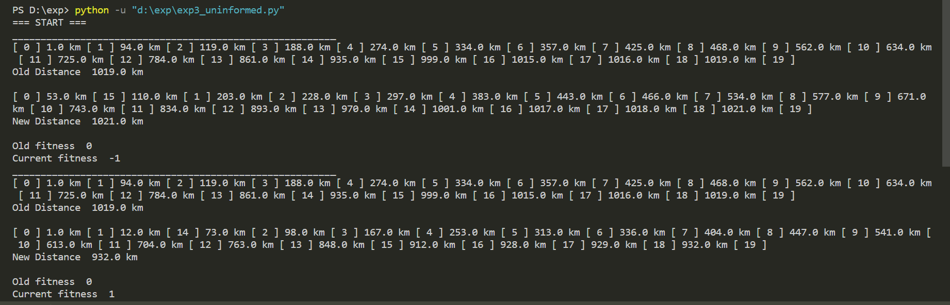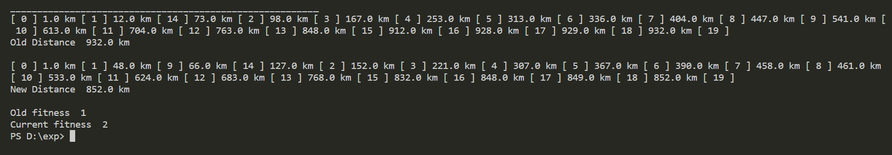

**Hill Climbing**

**Code:**

import numpy as np

*def* find_neighbours(*state*, *landscape*):

    neighbours = []

    dim = landscape.shape

    # left neighbour

    if state[0] != 0:

        neighbours.append((state[0] - 1, state[1]))

    # right neighbour

    if state[0] != dim[0] - 1:

        neighbours.append((state[0] + 1, state[1]))

    # top neighbour

    if state[1] != 0:

        neighbours.append((state[0], state[1] - 1))

    # bottom neighbour

    if state[1] != dim[1] - 1:

        neighbours.append((state[0], state[1] + 1))

    # top left

    if state[0] != 0 and state[1] != 0:

        neighbours.append((state[0] - 1, state[1] - 1))

    # bottom left

    if state[0] != 0 and state[1] != dim[1] - 1:

        neighbours.append((state[0] - 1, state[1] + 1))

    # top right

    if state[0] != dim[0] - 1 and state[1] != 0:

        neighbours.append((state[0] + 1, state[1] - 1))

    # bottom right

    if state[0] != dim[0] - 1 and state[1] != dim[1] - 1:

        neighbours.append((state[0] + 1, state[1] + 1))

    return neighbours

# Current optimization objective: local/global maximum

*def* hill_climb(*curr_state*, *landscape*):

    neighbours = find_neighbours(curr_state, landscape)

*bool*

    ascended = False

    next_state = curr_state

    for neighbour in neighbours: #Find the neighbour with the greatest value

        if landscape[neighbour[0]][neighbour[1]] > landscape[next_state[0]][next_state[1]]:

            next_state = neighbour

            ascended = True

    return ascended, next_state

*def* __main__():

    landscape = np.random.randint(1, *high*=50, *size*=(10, 10))

    print(landscape)

    start_state = (3, 6)  # matrix index coordinates

    current_state = start_state

    count = 1

    ascending = True

    while ascending:

        print("\nStep #", count)

        print("Current state coordinates: ", current_state)

        print("Current state value: ", landscape[current_state[0]][current_state[1]])

        count += 1

        ascending, current_state = hill_climb(current_state, landscape)

    print("\nStep #", count)

    print("Optimization objective reached.")

    print("Final state coordinates: ", current_state)

    print("Final state value: ", landscape[current_state[0]][current_state[1]])

__main__()

**Output**

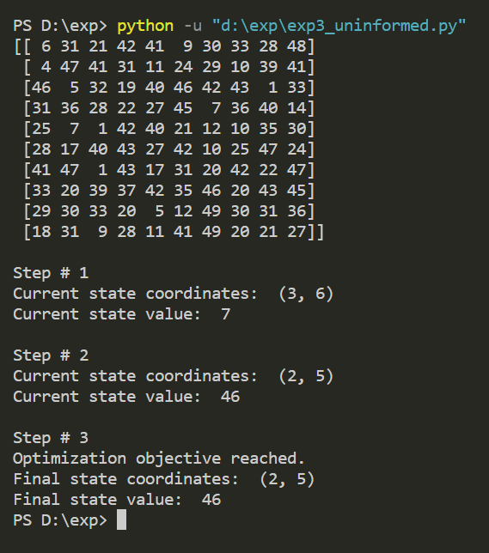

**Exp 7 - Genetic Algorithm**

**Code**

import random

*def* score(*parent1*, *parent2*):

   # doing crossover

   for i in range(len(parent1)-1, len(parent1)-4, -1):

       parent1[i], parent2[i] = parent2[i], parent1[i]

   #doint mutation by randomly selecting the genes

   mutation_index = [random.randint(0, len(parent1)-1) for i in range(len(parent1)//2)]

   for i in mutation_index:

       if parent1[i] == '0':

           parent1[i] = '1'

       else:

           parent1[i] = '0'

       if parent2[i] == '0':

           parent2[i] = '1'

       else:

           parent2[i] = '0'

   score1 = parent1.count('1')

   score2 = parent2.count('1')

   #checking which child is better with more gene of type1

   if score1 > score2:

       return [''.join(parent1), score1]

   else:

       return [''.join(parent2), score2]

*def* genetic_algo():

   # Taking input as no. of parents

   n = *int*(input('Enter the number of parents: '))

   parents = []

   #taking parents genes as input 1 by 1

   for i in range(n):

       parents.append(*list*(input(*f*'Enter the parent{i+1}: ')))

   results = []

   #finding the score and storing it in results

   for i in range(len(parents)):

       for j in range(i+1, len(parents)):

           arr = [parents[i].copy(), parents[j].copy()]

           scores = score(parents[i], parents[j])

           results.append(scores + arr)

   # finding the best score among all combination of parents

   results.sort(*key*=*lambda* *x*: x[1], *reverse*=True)

   print(*f*'The best offspring among the parents is : {results[0][0]} and the parents are {"".join(results[0][2])} and {"".join(results[0][3])}')

genetic_algo()

**Output**

